Supplementary Materials
Supplementary Table 1 Baseline characteristics stratified by Lp(a) and PNI level.
Supplementary Table 2 & 3 Subgroup analysis of association between the Lp(a) and PNI and the risk of all-cause mortality.
Supplementary Fig. 1 Correlations between Lp(a), total cholesterol, CONUT ,PNI, its components and LDL-C.
Supplementary Fig. 2 Nonlinear associations of prognostic nutritional index and lipoprotein(a) with all-cause and cardiovascular mortality.

Supplementary Table 1. Baseline characteristics between survivors and non-survivors in patients with coronary artery disease.
Characteristic | Overall | Survivors | Non-Survivors | P-value
 | (N=47,482) | (N=42,253) | (N=5229)
Demographic characteristics
Age, years | 62.8 (10.7) | 62.08 (10.53) | 68.46 (10.05) | <0.001
Female, n (%) | 11332 (23.9) | 10220 (24.2) | 1112 (21.3) | <0.001
Current smoker, n (%) | 12996 (36.2) | 11370 (35.9) | 1626 (38.0) | 0.006
Coexisting conditions
AMI, n (%) | 9670 (20.4) | 8519 (20.2) | 1151 (22.0) | 0.002
PCI, n (%) | 35300 (74.3) | 31514 (74.6) | 3786 (72.4) | <0.001
CHF, n (%) | 7363 (15.5) | 5969 (14.1) | 1394 (26.7) | <0.001
Hypertension, n (%) | 26514 (55.8) | 23301 (55.1) | 3213 (61.4) | 0.002
Diabetes mellitus, n (%) | 17406 (36.7) | 14986 (35.5) | 2420 (46.3) | <0.001
CKD, n (%) | 37594 (79.3) | 7542 (17.9) | 2248 (43.1) | <0.001
Anaemia, n (%) | 14956 (31.5) | 12356 (29.2) | 2600 (49.7) | <0.001
Atrial fibrillation, n (%) | 1887 (4.0) | 1474 (3.5) | 413 (7.9) | <0.001
Stroke, n (%) | 2801 (5.9) | 2292 (5.4) | 509 (9.7) | <0.001
Laboratory examination
Lymphocyte, 109/L | 46.62 ± 5.82 | 1.94 ± 0.69 | 1.74 ± 0.70 | <0.001
ALB, g/L | 16.99 [8.84, 35.60] | 47.51 ± 4.98 | 34.90 ± 2.75 | <0.001
PNI | 1.91± 0.69 | 47.04 ± 5.63 | 43.23 ± 6.22 | <0.001
Lipoprotein(a), mg/dL | 37.05 ± 4.14 | 16.50 [8.64, 34.72] | 23.97 [12.96, 45.70] | <0.001
HbA1c, % | 6.51 ± 1.42 | 6.48 ± 1.40 | 6.78 ± 1.54 | <0.001
Total cholesterol, mmol/L | 4.55 ± 1.26 | 4.57 ± 1.27 | 4.42 ± 1.19 | <0.001
HDL-C, mmol/L | 1.01 ± 0.26 | 1.01 ± 0.26 | 0.98 ± 0.27 | <0.001
LDL-C, mmol/L | 2.86 ± 0.99 | 2.88 ± 1.00 | 2.72 ± 0.95 | <0.001
Triglyceride, mmol/L | 1.69 ± 1.27 | 1.71 ± 1.28 | 1.55 ± 1.12 | <0.001
Hemoglobin,g/L | 134.10 ± 17.46 | 135.07 ± 16.86 | 126.26 ± 20.04 | <0.001
APOA, g/L | 1.13 ± 0.26 | 1.14 ± 0.26 | 1.06 ± 0.26 | <0.001
APOB, g/L | 0.87 ± 0.25 | 0.87 ± 0.25 | 0.84 ± 0.23 | <0.001
eGFR, mL/min/1.73 m2 | 78.2 ± 26.6 | 80.00 ± 25.86 | 63.34 ± 27.82 | <0.001
LVEF,% | 59.1 ± 11.8 | 59.92 ± 11.19 | 52.76 ± 14.58 | <0.001
Medicine
RASi, n (%) | 33236 (70.8) | 29689 (70.7) | 3547 (71.7) | <0.001
β-blocker, n (%) | 37828 (80.6) | 33908 (80.8) | 3920 (79.2) | 0.009
Statins, n (%) | 44886 (95.7) | 40215 (95.8) | 4671 (94.4) | <0.001
Aspirin, n (%) | 43174 (92.0) | 38773 (92.4) | 4401 (88.9) | <0.001
Abbreviations: AMI, acute myocardial infarction; PCI, percutaneous coronary intervention; CHF, congestive heart failure; CKD, chronic kidney disease; HDL-C, high-density lipoprotein cholesterol; LDL-C, low-density lipoprotein cholesterol; RASi, renin angiotensin system inhibitor.
Data are presented as the mean value (standard deviation), median [interquartile range] or number of participants (percentage).
Supplementary Table 2. Subgroup analyses of association between the Lp(a) and the risk of all-cause mortality.
Variables | N (%) | HR (95%CI) | P | P for interaction
Age ≥ 65 |  |  |  | 0.859
No | 26136 (55.04) | 1.15 (1.11 ~ 1.19) | <0.001
Yes | 21346 (44.96) | 1.17(1.11 ~ 1.23) | <0.001
Gender |  |  |  | 0.879
Male | 36150 (76.13) | 1.16 (1.12 ~ 1.20) | <0.001
Female | 11332 (23.87) | 1.15(1.08 ~ 1.23) | <0.001
LDL-C ≥ 1.8 mmol/L |  |  |  | 0.291
No | 5718 (12.04) | 1.16 (1.08 ~ 1.26) | 0.005
Yes | 41758 (87.96) | 1.16 (1.13 ~ 1.20) | <0.001
AMI |  |  |  | 0.355
No | 37812 (79.64) | 1.15 (1.11 ~ 1.19) | <0.001
Yes | 9670 (20.36) | 1.16 (1.09 ~ 1.24) | 0.009
DM |  |  |  | 0.199
No | 30076 (63.33) | 1.13 (1.08 ~ 1.18) | 0.002
Yes | 17406 (36.67) | 1.21 (1.16 ~ 1.26) | 0.003

Supplementary Table 3. Subgroup analyses of association between the PNI and the risk of all-cause mortality.
Variables | N (%) | HR (95%CI) | P | P for interaction
Age ≥ 65 |  |  |  | <0.001
No | 26136 (55.04) | 0.94 (0.93 ~ 0.94) | <.001
Yes | 21346 (44.96) | 0.91 (0.90 ~ 0.94) | <.001
Gender |  |  |  | 0.046
Male | 36150 (76.13) | 0.92 (0.91 ~ 0.92) | <.001
Female | 11332 (23.87) | 0.90 (0.89 ~ 0.91) | <.001
LDL-C ≥ 1.8 mmol/L |  |  |  | 0.491
No | 5718 (12.04) | 0.92 (0.91 ~ 0.92) | 0.003
Yes | 41758 (87.96) | 0.92 (0.91 ~ 0.92) | <.001
AMI |  |  |  | 0.158
No | 37812 (79.64) | 0.91 (0.91 ~ 0.92) | <.001
Yes | 9670 (20.36) | 0.92 (0.91 ~ 0.92) | <.001
DM |  |  |  | 0.220
No | 30076 (63.33) | 0.91 (0.91 ~ 0.92) | 0.004
Yes | 17406 (36.67) | 0.91 (0.91 ~ 0.92) | <.001

Supplementary Table 4. Sensitivity analysis for prognostic nutritional index and lipoprotein(a) with all-cause and cardiovascular mortality

 | All-cause mortality |  |  | Cardiovascular mortality
 | Adjusted  HR(95%CI) |  |  | Adjusted  HR(95%CI)
 | Adjusted  HR(95%CI) | P |  | Adjusted  HR(95%CI) | P
Dichotomous PNI¹
Lpa-L / PNI-H | Reference | - |  | Reference | -
Lpa-M / PNI-H | 1.03 (0.91-1.18) | 0.630 |  | 1.01 (0.86-1.19) | 0.893
Lpa-H / PNI-H | 1.17 (1.04-1.32) | 0.012 |  | 1.21 (1.04-1.41) | 0.011
Lpa-L / PNI-L | 1.47 (1.34-1.62) | <0.001 |  | 1.52 (1.35-1.71) | <0.001
Lpa-M / PNI-L | 1.66 (1.50-1.84) | <0.001 |  | 1.83 (1.62-2.07) | <0.001
Lpa-H / PNI-L | 1.77 (1.60-1.94) | <0.001 |  | 2.06 (1.83-2.31) | <0.001
Exclude AMI and elevated hs-CRP (> 3 mg/L)
Lpa-L / PNI-H | Reference | - |  | Reference | -
Lpa-M / PNI-H | 0.92 (0.70-1.20) | 0.536 |  | 1.01 (0.73-1.40) | 0.970
Lpa-H / PNI-H | 0.99 (0.77-1.28) | 0.939 |  | 1.00 (0.73-1.37) | 0.987
Lpa-L / PNI-L | 1.59 (1.28-1.98) | <0.001 |  | 1.64 (1.25-2.15) | <0.001
Lpa-M / PNI-L | 1.62 (1.24-2.12) | <0.001 |  | 1.49 (1.06-2.11) | 0.022
Lpa-H / PNI-L | 1.50 (1.15-1.95) | <0.001 |  | 1.88 (1.39-2.55) | <0.001
¹PNI grouped by the median.
Adjusted for age, gender, hypertension, diabetes mellitus, dyslipidemia, chronic kidney disease, congestive heart failure, statin use, PCSK9 inhibitor use, coronary lesion characteristics, and neutrophil-to-lymphocyte ratio.

Supplementary Table 5. Additive effects of prognostic nutritional index and lipoprotein(a) on all-cause mortality and cardiovascular mortality.

Interactive items | Interactive effect (95% CI) ¹
 | All-cause mortality | P | CV mortality |  | P
Dichotomous PNI¹
RERI | 0.30 (0.14 - 0.43) | <0.001 | 0.32 (0.11 - 0.52) |  | 0.002
AP | 0.12 (0.07 - 0.16) | <0.001 | 0.12 (0.06 - 0.18) |  | <0.001
SI | 1.24 (1.15 - 1.33) | <0.001 | 1.24 (1.13 - 1.35) |  | <0.001
Exclude AMI and elevated hs-CRP (> 3 mg/L)
RERI | 0.27 (-0.17–0.63) | 0.187 | 0.45 (-0.13–1.04) |  | 0.131
AP | 0.20 (-0.14–0.33) | 0.095 | 0.22 (-0.04–0.48) |  | 0.097
SI | 1.23 (0.67–2.26) | 0.572 | 1.71 (0.75–3.93) |  | 0.382

Abbreviations: CV, cardiovascular; AP, proportion attributable to interaction; RERI, relative excess risk due to interaction; SI, synergy index; PNI, prognostic nutritional index.
¹ All models adjusted for age, gender, hypertension, diabetes, dyslipidemia, chronic kidney disease, acute myocardial infarction, congestive heart failure, statin use, PCSK9 inhibitor use, coronary lesion characteristics, and neutrophil-to-lymphocyte ratio.

Supplementary Fig. 1 Correlations between Lp(a), total cholesterol, CONUT ,PNI, its components and LDL-C.
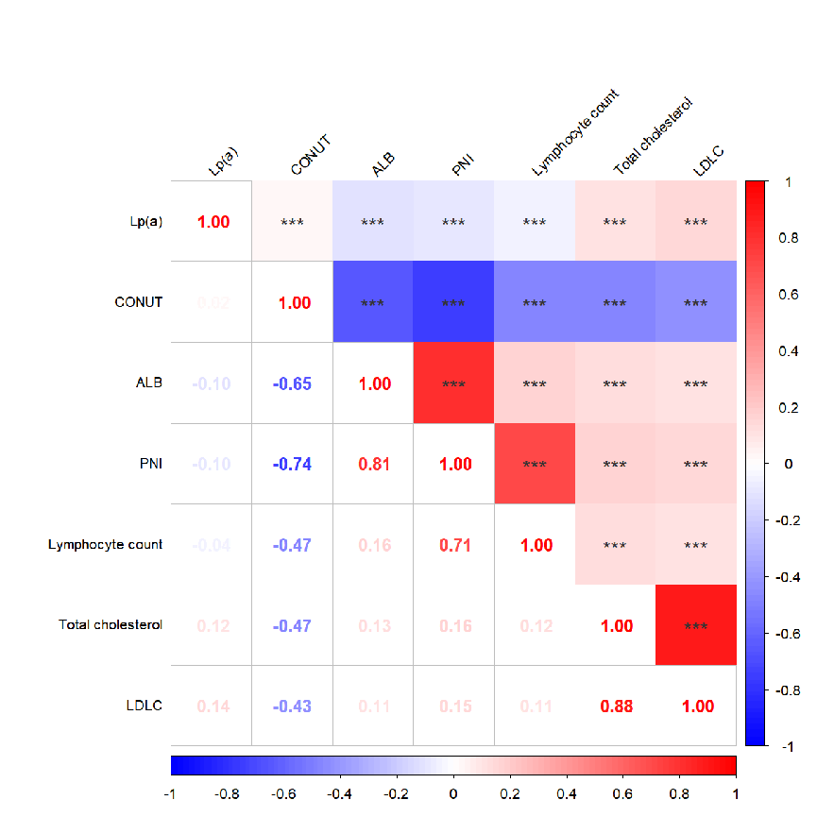
Lymphocyte count and albumin are components of PNI. *p-value for spearman correlation < 0.001.

Supplementary Fig. 2. Nonlinear associations of prognostic nutritional index and lipoprotein(a) with all-cause and cardiovascular mortality.
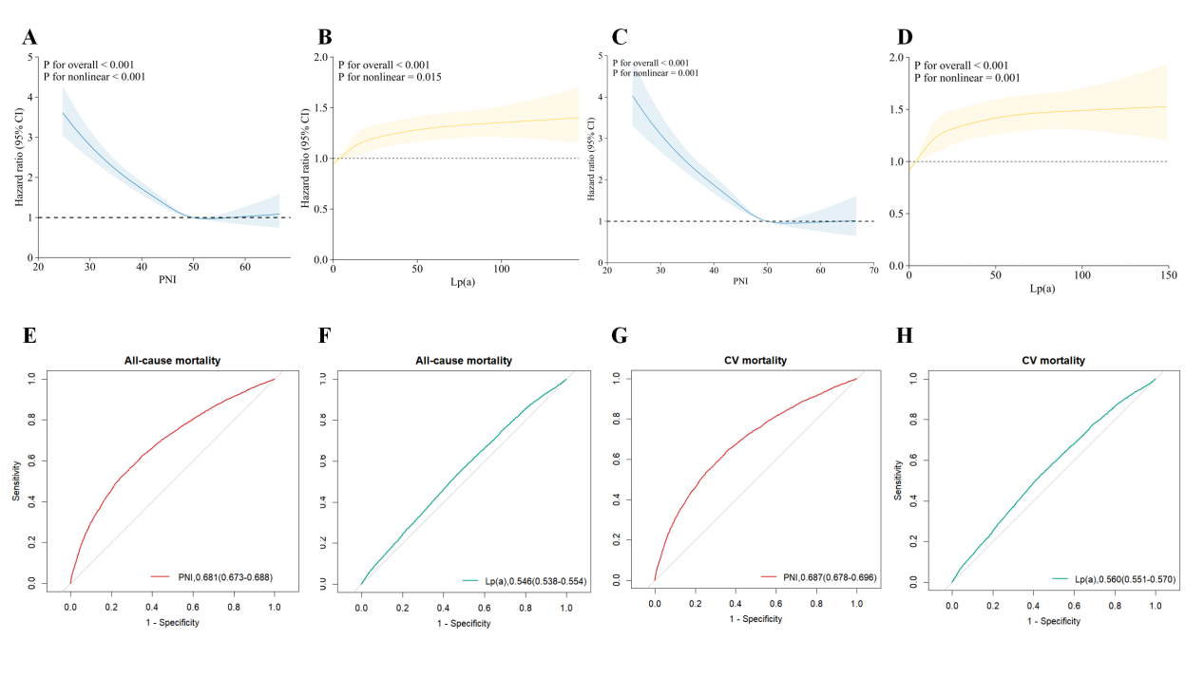
A - B. RCS analysis of the PNI and Lp(a) for all-cause mortality among patients with CAD; C - D. RCS analysis of the PNI and Lp(a) for cardiovascular mortality among patients with CAD; E - F. The ROC curves of PNI and Lp(a) as markers for predicting all-cause mortality among patients with CAD; G - H. The ROC curves of PNI and Lp(a) as markers for predicting CV mortality among patients with CAD.

